10-Mar-22

**Experiment 7 - Shift Reduce Parsing**

Dhawal Patil

RA1911003010575

CSE A2

Aim:

To write a program to show Shift Reduce Parsing using Python language.

Algorithm:

1. Start the program.
2. Initialize the required variables.
3. Enter the input symbol.
4. Perform the following:

for top-of-stack symbol, s, and next input symbol, a

Shift x: (x is a STATE number) Push a, then x on the top of the stack Advance ip to point to the next input symbol.

Reduce y: (y is a PRODUCTION number) Assume that the production is of the form A→ß Pop 2 * |ß| symbols of the stack.

At this point the top of the stack should be a state number, say s’. Push A, then goto of T[s’,A] (a state number) on the top of the stack. Output the production A→ß.

1. Print if string is accepted or not.
2. Stop the program.

Code:

gram = {

"E":["E*E","E+E","i"]

}

starting_terminal = "E"

inp = "i+i*i"

stack = "$"

print(f'{"Stack": <15}'+"|"+f'{"Input Buffer": <15}'+"|"+f'Parsing Action')

print(f'{"-":-<50}')

while True:

action = True

i = 0

while i<len(gram[starting_terminal]):

if gram[starting_terminal][i] in stack:

stack = stack.replace(gram[starting_terminal][i],starting_terminal)

print(f'{stack: <15}'+"|"+f'{inp: <15}'+"|"+f'Reduce S->{gram[starting_terminal][i]}')

i=-1

action = False

i+=1

if len(inp)>1:

stack+=inp[0]

inp=inp[1:]

print(f'{stack: <15}'+"|"+f'{inp: <15}'+"|"+f'Shift')

action = False

if inp == "$" and stack == ("$"+starting_terminal):

print(f'{stack: <15}'+"|"+f'{inp: <15}'+"|"+f'Accepted')

break

if action:

print(f'{stack: <15}'+"|"+f'{inp: <15}'+"|"+f'Rejected')

break

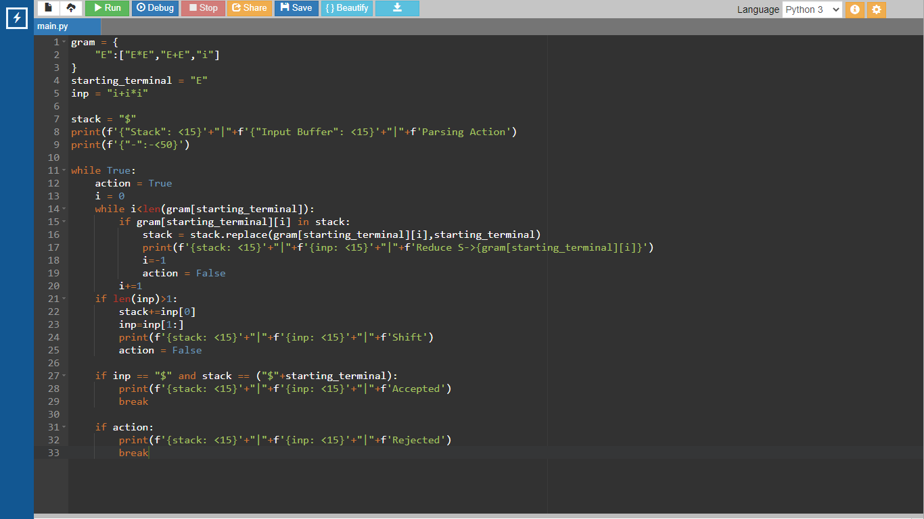

Output:

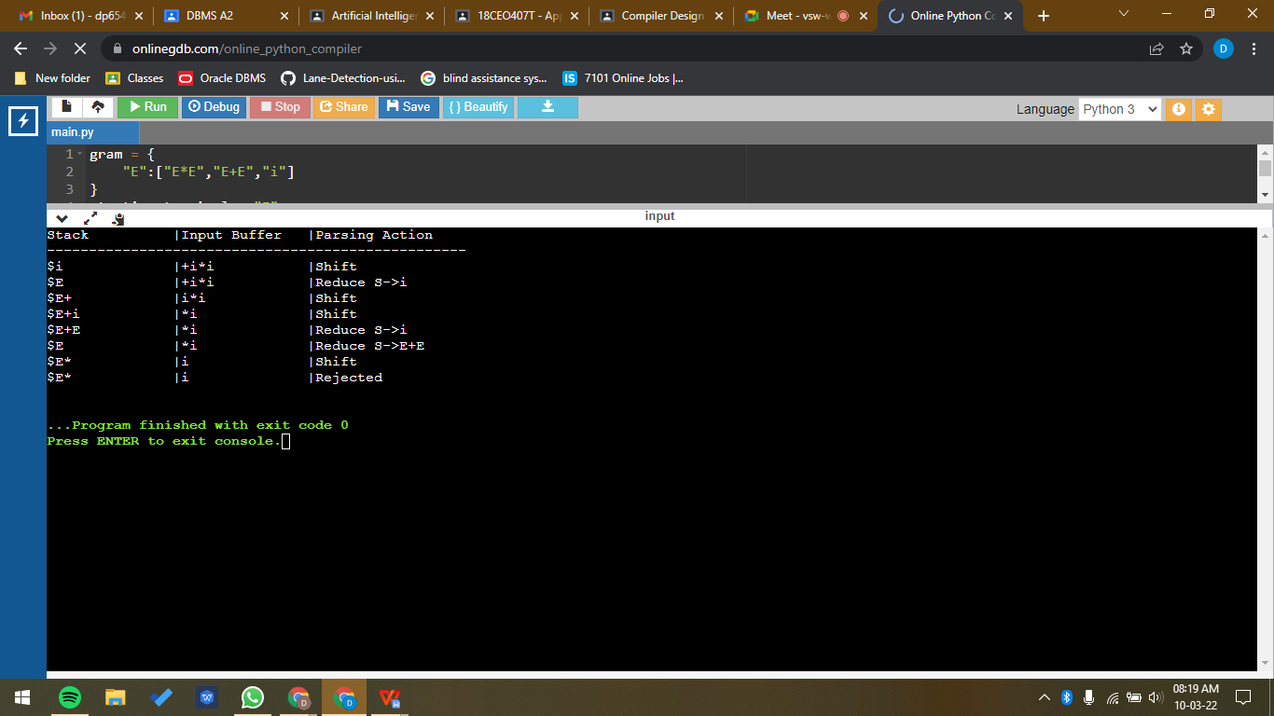

Result:

A program for Shift Reduce Parsing was run successfully.